Vrikshami complete script :
So this is the complete introduction to the interviewer
🔹 1. Project Introduction (30–40 sec)
“One of my major projects is Vrikshami, a web platform focused on tree adoption, NGO donations, and a homegrown plant marketplace.
The platform allows users to adopt trees through verified NGOs, make secure donations, receive a digital certificate of appreciation, and also buy or sell homegrown plants at a small scale.
The goal is to promote environmental sustainability while encouraging community participation.”

🔹 2. Tech Stack & Architecture (40–50 sec)
“Vrikshami is built using Node.js and Express.js on the backend with EJS for server-side rendering.
I used MongoDB with Mongoose for storing users, NGOs, adoptions, referrals, and plant listings.
Express-session is used for authentication sessions, Razorpay for payment processing, pdfmake for dynamic certificate generation, and Bootstrap, jQuery, and custom CSS for the frontend.
The project follows a basic MVC architecture, separating models, views, and controllers.”

🔹 3. Homegrown Plant Marketplace (45–50 sec)
“Apart from NGO adoption, I added a homegrown plant marketplace feature.
Logged-in users can list plants they have grown at home by providing details such as plant name, description, price, and images.
These listings are stored in MongoDB and displayed to other users in a marketplace-style view.
Buyers can browse these plants and place orders, which encourages small-scale eco-friendly selling and reuse of plants.”

🔹 4. Core NGO Adoption Flow (1 min)
“For the NGO adoption flow, users visit an NGO detail page that shows information, statistics, and adoption cost.
When they click ‘Donate & Adopt’, a modal opens where they select the number of trees, see the total amount dynamically calculated using jQuery, and enter their details.”

🔹 5. Razorpay Payment Integration (1–1.2 min)
“When the user proceeds to payment, the frontend sends the amount to a backend route called
POST /razorpay/create-order.
The backend validates the amount, converts it to paise, and creates a Razorpay order using the Razorpay Node SDK.
The returned orderId is then used to open the Razorpay Checkout popup on the frontend.
Once payment is successful, Razorpay triggers a handler function with a payment ID.”

🔹 6. Certificate Generation (1 min)
“After successful payment, the frontend calls
POST /generate-certificate.
On the backend, a separate certificate module built using pdfmake dynamically generates a PDF certificate by injecting the user’s name, NGO name, and date into a styled template.
The certificate is saved on the server and a downloadable link is returned and shown to the user.”

🔹 7. Saving Adoption & Order Details (30–40 sec)
“After certificate generation, I store the adoption details such as user information, payment ID, amount, and date in MongoDB.
Similarly, for the homegrown plant marketplace, order details are stored once a purchase is completed, maintaining a clear record of transactions.”

🔹 8. Referral System (40–50 sec)
“Vrikshami also includes a referral system.
Users can generate a referral link using their unique user ID.
When a new user signs up through this link, the backend identifies the referrer and rewards them with a ‘Referral Bonus’ badge, which is saved in the database.”

🔹 9. Closing Summary (20–30 sec)
“Overall, Vrikshami demonstrates my ability to build a full-stack, real-world application with features like secure payments, dynamic document generation, referral logic, and a small marketplace.
It showcases my experience with Node.js, Express, MongoDB, Razorpay integration, MVC architecture, and frontend interaction using EJS and jQuery.
I can explain any feature in more detail if required.”

Dynamic Certificate Generation
“In Vrikshami, certificate generation is automated.
When a user adopts a plant, a POST request is made to /generate-certificate with username and NGO name.
The backend validates data and then passes values to a reusable certificate generation module implemented using pdfMake. The PDF file is dynamically constructed with fonts, layout, and personalized fields and stored in /public/certificates. The backend finally returns the URL of the generated PDF, which is shown to the user for viewing or download.”
1️⃣ User Initiates Certificate Request
- The front-end sends a POST request (JSON) to:
👉 POST /generate-certificate
Example Request Body:
{
"userName": "Raj Pohekar",
"ngoName": "Sankalp Foundation"
}
This is done when:
✔ User adopts a plant
✔ User donates to an NGO

2️⃣ Express Backend Receives the Request
This happens in server.js or your route file:
app.use(express.urlencoded({ extended: true }));
app.use(express.json());

app.post('/generate-certificate', async (req, res) => {
try {
const userName = req.body.userName;
const ngoName = req.body.ngoName;

if (!userName || !ngoName) {
return res.status(400).send({ error: "User Name and NGO Name are required to generate certificate." });
}

const certificateUrl = await certificateGenerator.generatePdfCertificate(userName, ngoName);

res.json({ certificateUrl: certificateUrl });

} catch (error) {
console.error("Certificate generation error:", error);
res.status(500).send({ error: "Failed to generate certificate." });
}
});
What interviewer expects
✔ Validation is done
✔ Proper error handling
✔ Uses await, meaning async processing
✔ Returns JSON response (good design)

3️⃣ Backend Calls Certificate Generator Function
In certificate-generator.js:
module.exports = { generatePdfCertificate };
When called, it does 5 main things:

🌟 Step-by-Step Certificate Generation Logic

(a) Fonts and Directories Are Prepared
const fontDescriptors = {
Roboto: { ... }
};
✔ Custom fonts
✔ Ensures design consistency
Then creates directories:
fs.mkdirSync(certificatesDir, { recursive: true });
✔ Avoids runtime errors
✔ Allows storing generated certificates

(b) Certificate Document Structure is Defined
The docDefinition object includes:
✔ Title
✔ Recipient name
✔ NGO organization
✔ Motivational text
✔ Date
✔ Footer
Example:
{ text: 'Certificate of Appreciation', style: 'certificateTitle' },
{ text: userName, style: 'userNameStyle' },
{ text: ngoName, style: 'ngoNameStyle' },
You used correct styling:
- Large fonts for name
- Signature placeholders
- Alignment and colors

(c) pdfMake Creates the PDF Document
const printer = new pdfMake(fontDescriptors);
const pdfDoc = printer.createPdfKitDocument(docDefinition);
✔ PDF stream is created
✔ Not stored directly first
✔ Good memory-safe practice

(d) Stream Buffering Happens
const pdfChunks = [];
pdfDoc.on('data', (chunk) => {
pdfChunks.push(chunk);
});
This takes document chunks → merges → creates final buffer

(e) Finally, Certificate File Is Stored
const certificateFileName = `certificate-${Date.now()}.pdf`;
const certificatePath = path.join(__dirname, 'public', 'certificates', certificateFileName);

fs.writeFileSync(certificatePath, pdfBuffer);
✔ Unique filename using timestamp
✔ Saved inside /public/certificates

4️⃣ Backend Responds
You return:
{
"certificateUrl": "/certificates/certificate-1733459859893.pdf"
}
Referral feature implementation
🚀 Better & Correct Referral Flow (Session-Independent)
🌱 Step-by-Step
1️⃣ User A logs in → they generate referral link
https://vrikshami.com/signup?ref=VRK123
Where VRK123 = user_id of referrer

2️⃣ User B clicks link
→ Comes to signup page
→ You do not store session
Instead store in DB temporary table

3️⃣ At signup POST request
Send referralId explicitly:
Example request body:
{
"username": "User B",
"email": "xyz@gmail.com",
"password": "12345",
"referralCode": "VRK123"
}

4️⃣ Backend logic becomes:
app.post('/signup', async (req, res) => {
const { username, password, email, referralCode } = req.body;

const user_id = uuidv4();

await User.create({ username, password, email, user_id });

// Check referrer directly from DB (NO SESSION NEEDED)
if (referralCode) {
const referrer = await User.findOne({ user_id: referralCode });

if (referrer) {
referrer.badges.push("Referral Bonus");
await referrer.save();
}
}

res.redirect('/login');
});
MVC Diagram of the project
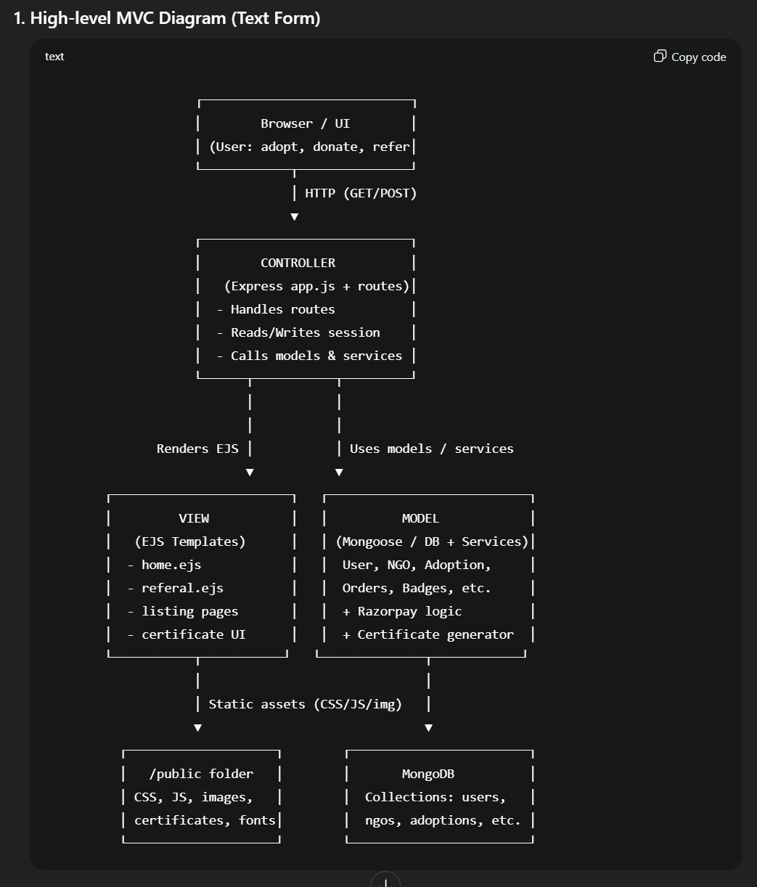
2. How to explain this to the interviewer (simple language)
You can explain it like this:
- View (V – EJS + Frontend)
  - All the pages the user sees are built using EJS templates like referal.ejs, listing pages, certificate UI, etc.
  - These views get dynamic data from the controller (like userId, NGO details, adoption info) and display it.
  - Static files like CSS, client-side JS, images, generated certificates, fonts are served from the /public folder.
- Controller (C – Express Routes in app.js)
  - Express routes act as controllers:
    - GET /referal → renders the referral page with userId.
    - POST /signup → handles user signup, referral session, and adds badges.
    - POST /generate-certificate → calls the certificate generator service and returns a certificateUrl as JSON.
    - Payment routes handle Razorpay order creation and verification.
  - Controllers:
    - Read/write req.session for login and referral.
    - Call Models to save or fetch data.
    - Decide which EJS view to render or whether to send JSON (like in certificate API).
- Model (M – Database + Business Logic / Services)
  - Models are your MongoDB/Mongoose schemas:
    - User (with user_id, badges, etc.).
    - NGO / Adoption / Orders / etc.
  - Business logic/services around models:
    - Referral logic – when a new user signs up with req.session.referral, you:
      - Find referrer in User model using user_id.
      - Add "Referral Bonus" badge and save.
    - Certificate generation – certificate-generator.js:
      - Uses pdfMake, fonts, and template styles.
      - Generates PDF, saves it to /public/certificates, returns file URL.
    - Payment (Razorpay) – creates orders, verifies payment, and then updates adoption/donation records.
- External Services & Files
  - Razorpay – integrated in the Controller/Service layer to handle payments.
  - pdfMake – part of the Model/Service layer used to dynamically generate certificates in PDF format.
  - Sessions – manage logged-in user and referral code via Express session.
Complete Razorpay Integration
1. User starts donation from NGO detail page (View – EJS + jQuery)
Tech used: EJS, Bootstrap, jQuery
- User opens an NGO detail page:
- <img src="<%= ngo.logo %>" ...>
- <h2><%= ngo.name %></h2>
- <p><%= ngo.description %></p>
- User clicks “Donate Now & Adopt a Tree” → opens the Bootstrap modal #donationModal.
- Inside the modal, user:
  - Chooses number of trees (#treeQuantity).
  - Enters name and email (#userName, #userEmail).
- updateTotal() runs when the quantity changes:
- const price = parseFloat($quantity.data('price'));
- let quantity = parseInt($quantity.val()) || 1;

- if (isNaN(quantity) || quantity < 1) {
- quantity = 1;
- $quantity.val(1);
- } else {
- const total = (price * quantity).toFixed(2);
- $totalAmount.text(total);
- }
👉 This keeps Total Amount accurate: pricePerTree × quantity.
- When user clicks “Donate & Adopt” (#proceedToPayment):
  - Frontend validates name & email:
  - if (!userName || !userEmail) {
  - // add is-invalid class and stop
  - return;
  - }
  - On success, it calls the backend to create an order:
  - $.post('/razorpay/create-order', { amount: totalAmount }, function (data) {
  - // continues with Razorpay Checkout...
  - });

2. Backend creates Razorpay Order (Controller – Express + Razorpay SDK)
Tech used: Node.js, Express.js, Razorpay Node SDK
Route:
app.post('/razorpay/create-order', async (req, res) => {
try {
const amount = req.body.amount;
if (!amount) {
return res.status(400).send({ error: "Amount is required" });
}

const options = {
amount: amount * 100, // convert ₹ to paise
currency: "INR",
receipt: 'receipt#1',
notes: {
notes_key_1: "Vrikshami Donation",
notes_key_2: "Plant Adoption"
}
};

razorpayInstance.orders.create(options, (err, order) => {
if (err) {
console.error("Razorpay Order Creation Error:", err);
return res.status(500).send({ error: "Razorpay order creation failed" });
}
res.json({ orderId: order.id });
});

} catch (error) {
console.error("Server error in Razorpay order creation:", error);
res.status(500).send({ error: "Internal server error" });
}
});
What happens here:
- Frontend sends amount (in rupees) to /razorpay/create-order.
- Server:
  - Validates that amount exists.
  - Converts amount → paise: amount * 100 (Razorpay expects the smallest unit).
  - Adds metadata in notes (for your identification: donation & plant adoption).
- Uses razorpayInstance.orders.create to hit Razorpay’s API.
- On success, sends orderId back to the browser as JSON:
- { "orderId": "<razorpay_order_id>" }

3. Razorpay Checkout opens on frontend (Client – Razorpay Checkout.js)
Tech used: Razorpay Checkout.js, jQuery, EJS data
After it gets orderId, frontend configures Razorpay:
$.post('/razorpay/create-order', { amount: totalAmount }, function (data) {
var options = {
"key": "rzp_test_dbSUObAxmftjkG", // test key
"amount": totalAmount * 100, // again in paise
"currency": "INR",
"order_id": data.orderId, // from server
"name": "<%= ngo.name %> - Tree Adoption",
"description": "Donation for Tree Adoption",
"image": "<%= ngo.logo %>",
"handler": function (response) {
// called AFTER successful payment
},
"prefill": {
"name": userName,
"email": userEmail
},
"notes": {
"address": "Example address"
},
"theme": {
"color": "#C0EBA6"
}
};
var razorpay = new Razorpay(options);
razorpay.open();
}, 'json');
Flow here:
- Razorpay Checkout popup opens with your order, amount, NGO name, logo, and user prefilled data.
- User completes payment using any Razorpay-supported method (UPI, Card, etc.).
- On success, Razorpay calls your handler callback function and passes payment details:
- "handler": function (response) {
- console.log("Razorpay Payment Response:", response);
- var paymentId = response.razorpay_payment_id;
- // Then you trigger certificate generation + DB save
- }
No webhooks here – you’re using client-side handler after successful payment.

4. After payment: generate certificate (calls your certificate API)
Tech used: jQuery AJAX, Express.js, pdfmake
Inside the handler after successful payment:
$.post('/generate-certificate', { userName: userName, ngoName: '<%= ngo.name %>' }, function (certificateData) {
// success UI + download link + DB save
}, 'json')
This calls your existing /generate-certificate route, which uses certificateGenerator.generatePdfCertificate(...) to:
- Build a PDF in memory with pdfmake.
- Save it to public/certificates/certificate-<timestamp>.pdf.
- Return a URL like /certificates/certificate-123456789.pdf.
Frontend then:
- Shows a success message in the modal (with paymentId, NGO name, number of trees).
- Adds a Download Certificate link using the certificateUrl returned.
- Adds a “Done” button that sends final details to backend:
- $.post('/ngo/<%= ngo._id %>', {
- userName: userName,
- userEmail: userEmail,
- paymentId: paymentId,
- totalAmount: totalAmount,
- date: currentDate
- }, function (response) {
- window.location.href = "/adoption";
- });
This last request is where you typically:
- Save adoption/donation details in DB (Model layer).
- Then redirect user to /adoption page (confirmation / history).

5. How to explain this in an interview (short version)
You can say something like:
“For Razorpay integration in Vrikshami, I built a full flow:
- On the NGO detail page, the user selects number of trees and enters their details. I calculate the total amount on the client side using jQuery.
- When they click ‘Donate & Adopt’, I send the amount to a Node.js + Express route /razorpay/create-order, where I use the Razorpay Node SDK to create an order (amount converted to paise, currency set to INR, and notes added).
- The backend returns the orderId, and on the frontend I initialize Razorpay Checkout.js with that orderId. After a successful payment, Razorpay triggers a handler callback where I:
  - Call another Express endpoint /generate-certificate that uses pdfmake to generate a personalized ‘Certificate of Appreciation’ PDF.
  - Dynamically show a success message, provide a download link for the certificate, and send a final POST to save the donation/adoption details in the database before redirecting the user to the adoption page.
This flow ties UI, payment gateway, certificate generation, and DB persistence together.”

Complete Project Script
🔹 1. Project Introduction (high-level)
“One of my main projects is Vrikshami, a web platform for tree adoption and NGO donations.
The idea is: users can choose an NGO, donate to adopt trees, and after successful payment they get a digital certificate of appreciation.
The platform also has a referral system to grow the community and a small plant shop concept for homegrown plants.”

🔹 2. Tech Stack (always mention technologies)
“Technically, it’s a Node.js + Express based application with EJS templating on the front end.
I’ve used MongoDB for storing users, NGOs and adoption details,
Express-session for authentication sessions,
Razorpay for payment integration,
pdfmake for dynamic certificate generation, and
Bootstrap + custom CSS + jQuery on the front end for responsive UI and AJAX.”

🔹 3. Architecture / MVC Flow (system design style)
“I followed a simple MVC-style architecture:
- Model: MongoDB models like User, NGO, Adoption, etc. store users, NGOs and donation/adoption records.
- View: EJS templates (views/listing/ngo-detail.ejs, views/listing/referal.ejs etc.) render the HTML pages.
- Controller / Routes: Express routes handle requests – for example:
  - /ngo/:id to show NGO details,
  - /razorpay/create-order to create Razorpay orders,
  - /generate-certificate to generate certificates,
  - /signup to handle signup and referrals.
The browser sends a request → Express route executes the business logic → accesses MongoDB models → renders an EJS view or returns JSON (for AJAX) back to the frontend.”
You can also add:
“For for dynamic parts like payment, I use AJAX (via jQuery) to call backend routes without reloading the page.”

🔹 4. Core User Flow: Tree Adoption + Razorpay + Certificate
Explain this clearly; this is your hero flow.
“The main flow is adopting a tree through an NGO:
- The user visits the NGO detail page. This page is rendered by EJS and shows NGO logo, description, stats, and a ‘Donate & Adopt’ button.
- When they click the button, a Bootstrap modal opens where they:
  - choose number of trees,
  - see the total amount (calculated in the frontend using jQuery),
  - enter their name and email.
- On clicking ‘Proceed to Payment’, I use jQuery’s $.post to call my backend route
POST /razorpay/create-order with the total amount.
- In the backend, the Express route:
  - validates the amount,
  - creates a Razorpay order using the Razorpay Node SDK,
  - and sends back the orderId to the frontend.
- On the frontend, I initialize Razorpay Checkout with:
  - the orderId from the backend,
  - amount, currency, NGO name, logo, and prefilled user name/email.
- The Razorpay popup handles the actual payment.
On success, Razorpay calls the handler function in my script with the razorpay_payment_id.
- Inside this handler:
  - I call another backend route POST /generate-certificate via $.post, sending userName and ngoName.
  - The backend uses pdfmake to build a dynamic PDF certificate: it sets page layout, background image, styles, and injects the user’s name, NGO name, date, and a thank-you message.
  - It writes the PDF file to /public/certificates and returns a certificateUrl.
- On the frontend, when I receive certificateUrl:
  - I show a success message inside the modal (with name, number of trees, payment id, etc.),
  - I add a ‘Download Certificate of Appreciation’ link so the user can download the PDF,
  - I create a ‘Done’ button which makes another POST to /ngo/:id to save the adoption details (user, email, payment ID, amount, date) in the database, and then redirect to the adoption page.”
If they say “what was challenging?”:
“The challenging part was coordinating the async flow: front-end → create order → Razorpay payment → certificate generation → saving adoption info. I had to carefully handle errors at each step and make sure the user always gets feedback, especially if payment succeeds but certificate fails.”

🔹 5. Certificate Generation – Short Interview Explanation
“The certificate generation is done completely in the backend using pdfmake:
- I created a separate module certificate-generator.js which exports a function generatePdfCertificate(userName, ngoName).
- It defines a docDefinition object with:
  - page size, margins,
  - a light background image,
  - styled text for title, user name, NGO, date, and footer.
- pdfmake creates a PDF stream; I collect the chunks into a buffer, write it as certificate-<timestamp>.pdf in /public/certificates, and then return a public URL like /certificates/certificate-1234.pdf.
- The API route /generate-certificate validates input, calls this function, and responds with { certificateUrl } which the frontend uses to show a download link.
This way the certificate is dynamic, automated, and tied directly to a successful donation flow.”

🔹 6. Referral System Flow (brief but clear)
“I also implemented a basic referral system:
- On the Referral page, I show the logged-in user’s userId and give them a button to generate a referral link like:
http://localhost:3000/?ref=<userId>.
- jQuery sets this link in a text box and also prepares WhatsApp and Email share links with that URL embedded.
- When a new user lands via this link, the ref query parameter is stored in req.session.referral.
- During signup (POST /signup), after creating the new user:
  - I check req.session.referral.
  - If it’s set, I find the referrer in the database,
  - push a "Referral Bonus" badge into their badges array and save it.
  - Then clear the referral from session.
So the referrer gets a badge as a reward whenever someone signs up using their referral link.”
If they ask about limitations, you can say:
“Right now the referral is based on session storage and query param. A more robust approach would be to store the referral code directly in the new user’s record so that it works even if session is lost.”

🔹 7. How to end your explanation
“Overall, Vrikshami shows my ability to:
- design a real-world flow (donation + adoption),
- work with Node.js, Express, MongoDB,
- integrate payment gateway (Razorpay) end-to-end,
- build dynamic PDFs with pdfmake,
- and add features like referral system, badges, and proper UI with Bootstrap & jQuery.
If you’d like, I can walk you through any module in detail — for example, the Razorpay integration or the certificate generator.”

